Spinach Risotto Topped with Spiced Chickpea Crumble

[Get this meal!](https://www.thepurplecarrot.com/users/sign_up) 

Ingredients

1. 1 can chickpeas
2. Salt and pepper*
3. 2 tablespoons extra virgin olive oil*
4. 1 onion
5. 3/4 cups Arborio rice
6. 1/2 cup dry white wine or water*
7. 1 tablespoon white miso paste
8. 2 packed cups baby spinach leaves
9. 1/8 teaspoon cayenne pepper
10. 1/8 teaspoon paprika
11. *not included

SUMMARY

* Prep time: 45 minutes
* Servings: 2

NUTRITION

* Calories: 587
* Carbohydrates: 90
* Fat: 18
* Protein: 16

You might have heard that risotto is hard to make—that’s not true, as this creamy, rich version demonstrates perfectly. And with the alluring flavor of miso and a bit of spiciness from cayenne and paprika, it’s really tasty. The chickpea crumble adds a crisp counterpoint in every bite, and is a protein-packed garnish you can use in many other dishes.

Instructions

1.

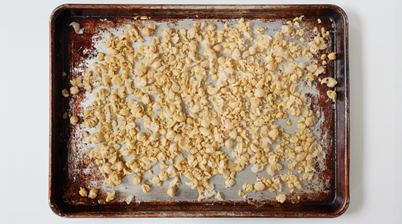

Heat the oven to 400°F. Drain the chickpeas into a colander, rinse, and drain again; spread them into a rimmed baking sheet. Sprinkle with salt and pepper and mash them lightly with a fork. Drizzle with 1 tablespoon oil and roast, turning with a spatula once or twice, until crisp and lightly browned, 15 to 20 minutes.

2.

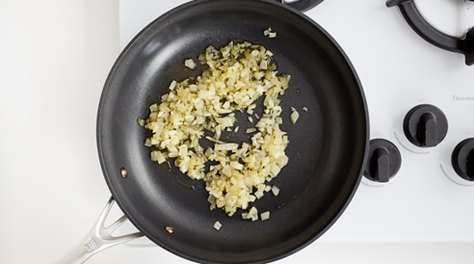

Trim, peel, and chop the onion. Put 2 cups hot tap water in a large pot or kettle over medium-high heat. Put the remaining tablespoon oil in a medium skillet or pot over medium heat. When it’s hot, add the onion and cook, stirring occasionally until it softens, 3 to 5 minutes.

3.

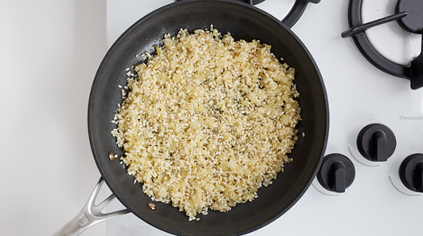

Add the rice and cook, stirring occasionally, until it is glossy and coated with oil, 2 or 3 minutes. Add a little salt and pepper, then the 1/2 cup white wine or water. Stir and let the liquid bubble away.

4.

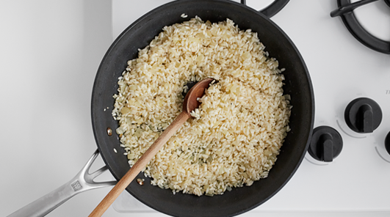

Begin to add the hot water from the pot or kettle, 1/2 cup at a time, stirring after each addition and frequently as the rice cooks, and adjusting the heat as necessary so the mixture bubbles enthusiastically without burning. When the water is just about evaporated, add more. The mixture should be neither soupy nor dry.

5.

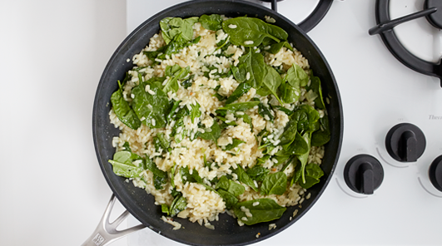

Begin tasting the rice after it’s been cooking about 15 minutes; you want it to be tender but with still a tiny bit of crunch; it could take as long as 30 minutes to reach this stage. When it’s ready stir in the miso paste and spinach. Taste and adjust the seasoning. Remove the chickpeas from the oven, sprinkle with the cayenne and paprika and toss well. To serve, divide the risotto among shallow bowls and top with crumbled chickpeas.